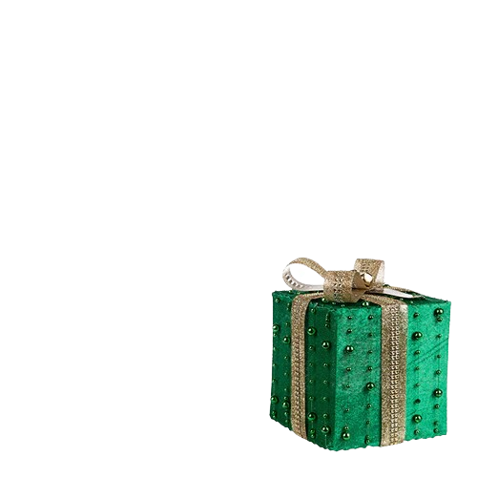

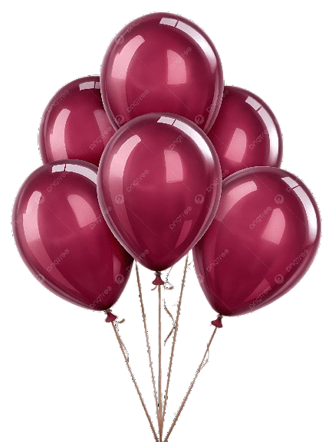
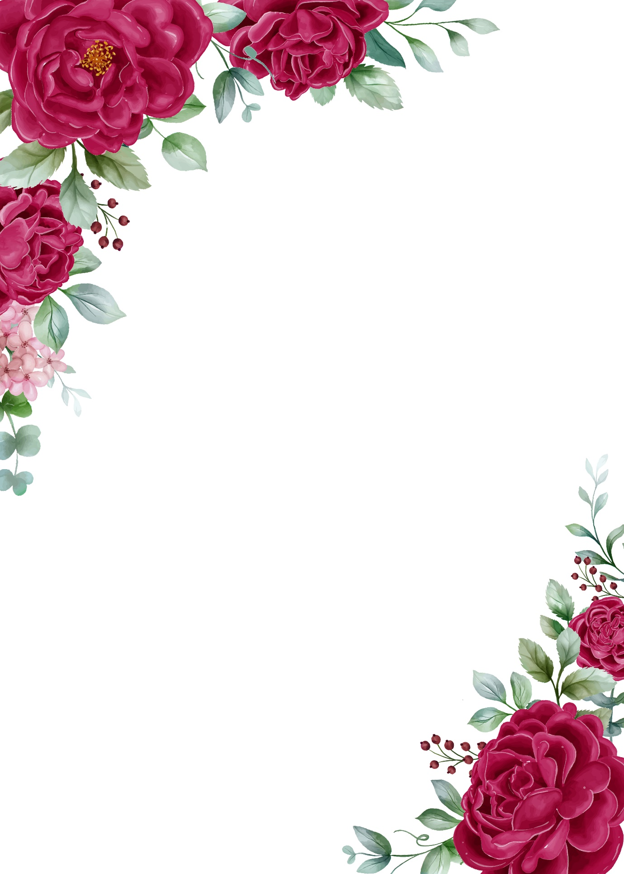
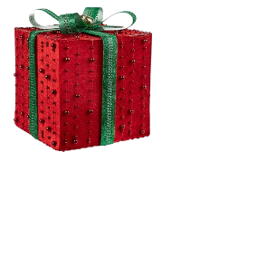
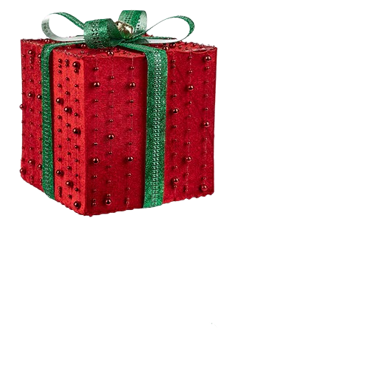


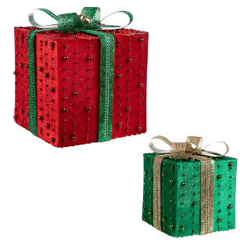
Lots Of Love From
saduu …
Happy Birthday, anuu🎉✨
Wishing you a day filled with laughter, love, and all your favourite things. May this year bring you endless happiness, exciting opportunities, and beautiful moments to cherish. Keep shining and being your amazing self! 💖
Have the best birthday ever! 🎂

